**Project Design Phase-II**

**Technology Stack (Architecture & Stack)**

|  |  |
| --- | --- |
| Date | 03 November 2022 |
| Team ID | PNT2022TMID42723 |
| Project Name | Project - SmartFarmer – IoT  Enabled Smart Farming Application |
| Maximum Marks | 4 Marks |

**Technical Architecture:**

The Deliverable shall include the architectural diagram as below and the information as per the table1 & table 2

**Example:  uses weather data or soil moisture data to determine the irrigation need of the landscape.**

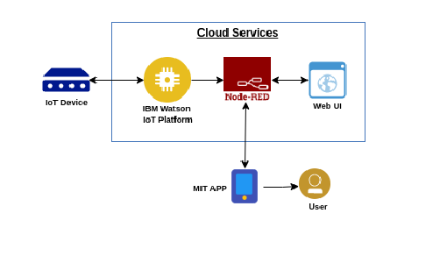

**Table-1 : Components & Technologies:**

|  |  |  |  |
| --- | --- | --- | --- |
| **S.No** | **Component** | **Description** | **Technology** |
|  | IOT Devices | Nonstandard computing devices that connect wirelessly to a network and have the ability to transmit data, such as the many devices on the internet of things (IoT).e.g.Motion Detection, Augmented Reality Glasses and etc. | * Non-industrial IoT. Smart Buildings,Reports & Databases,Global IoT Enterprise Spending,Cellular IoT Connectivity & LPWA Market. Cellular IoT Module and Chipset Market and etc. |
|  | MIT Application | To allow people to design and create apps to interact with physical devices. | Java / Scheme/Kava |
|  | Web UI | The user interface (UI) is the point of human-computer interaction and communication in a device | React /Angular/Flutter /Vue.js /JQuery /Emberjs / Semantic |
|  | Node Red | A programming tool for wiring together hardware devices, apis and online services in new and interesting ways | [JavaScript](https://en.wikipedia.org/wiki/JavaScript)/Node.JS/JSON |
| 5. | Cloud Database | A fully managed, cloud-hosted service that makes it simple to derive value from Internet of Things (IoT) devices. | IBM DB2, IBM Cloudant etc. |
| 6. | Ibm Watson IOT Platform | File storage requirements | Java/C/JavaScript. |

**Table-2: Application Characteristics:**

| **S.No** | **Characteristics** | **Description** | **Technology** |
| --- | --- | --- | --- |
|  | Open source | **Node Red** used for open-sources. It is open source and was originally created by the IBM Emerging Technology organisation. | It is used to wiring together hardware devices,**API**s and online services in new and interesting ways.Is and online services in new and interesting ways. |
|  | Security Implementations | Device authentication.  Device authorization. Data encryption. Strong keys or certificates management plan for all levels. | * E.g. Smart Homes,Smart City,Self-driven Cars,IoT Retail Shops,Farming,   Wearables,SmartGrids,Industrial Internet and etc. |
|  | Scalable Architecture | **MIT app** is used for open-sources | **MIT** is a free, cloud-based service that allows you to make your own mobile apps using a blocks-based programming language. |
|  | Availability | It provide a clean and simple UI where you can simply and easily add and manage your devices, control access to your **IoT** service, and monitor your usage.E.g IOT and Web UI | Watson IoT Platform is used by firms across industries including transport, retail, manufacturing, construction, mining and shipping. |
|  | Performance | As part of performance testing, there is need to simulate devices from different locations (to simulate latency) with required network technolo- gies like 2G, 3G, 4G, Bluetooth, etc. | It is a collection of services and software that integrates data received from various IoT devices. It uses machine learning or **artificial intelligence (AI)** technology to analyze this data and make informed decisions. |